Employee Skill Management System

**Question**: Develop an Application for Skill Management of Employees, Create Dashboard to display skill wise and other KPIs, we should be able to search for employees based on skills , rating, experience, certifications etc

Employee Id: 70983718 Name: Navneeth N

Introduction: An application called the Employee Skill Management System will be created to manage the skills of employees within an organisation. The programme will assist the HR department in monitoring employee skill levels, experience, rating and identifying areas where training is required. The programme will also assist the employees in determining their strengths and shortcomings and in making appropriate plans for their professional development.

Objective: This application's goals are to manage employee skills, develop a consolidated database of employee skills, and make employee skill data accessible to all users.

Features:

The Employee Skill Management System will have the following features:

User Management: The system will support a variety of user roles, including Employee, Team Lead, and HR Manager. Users will each have unique access privileges and permissions.

Skills Assessment: The system will include a skill assessment module that will enable HR Managers to evaluate employees' skills and determine which areas they require training in.

Training Management: The solution would enable HR Managers to designate training programmes to employees in accordance with their skill gaps. The given training programmes can be viewed by the employees, who can then mark them as finished.

Rating: The system will offer several reports, including skill gap analyses, training reports, and employee skill reports. These reports will aid HR managers in determining an employee's skill set and career development strategy to rate them.

Experience: Employees based on their period of their training , skill assessments, and skills gained.

Technology Stack:

The following technology stack will be used for the development of the Employee Skill Management System:

Frontend: Java Angular, HTML, CSS (VS Code)

Backend: Node.js, Spring Boot (Eclipse IDE)

API: RESTful API with Spring and Postman

Deployment: AWS

Implementation:

Frontend:

A dashboard with employee information should be constructed using Angular in accordance with the stated task. Employee details include employee id, name, skill, experience, rating, certifications, and key performance indicators (KPI).

* The skill-based employee information is shown on the dashboard on the home page.
* Employees can register by adding their skills and information on the Register page.
* The information about the personnel is shown on the Employee page.
* The aim is to be able to search for employees based on abilities, rating, experience, and certifications. Employee data are provided on the Search page.
* A custom filter pipe is used to search the element, and the filtered information about the employees is displayed according to the searching property.

Login Page:

Username: admin

Password: admin

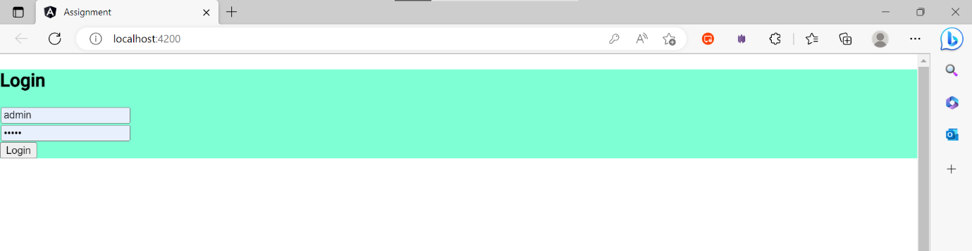Home Page:

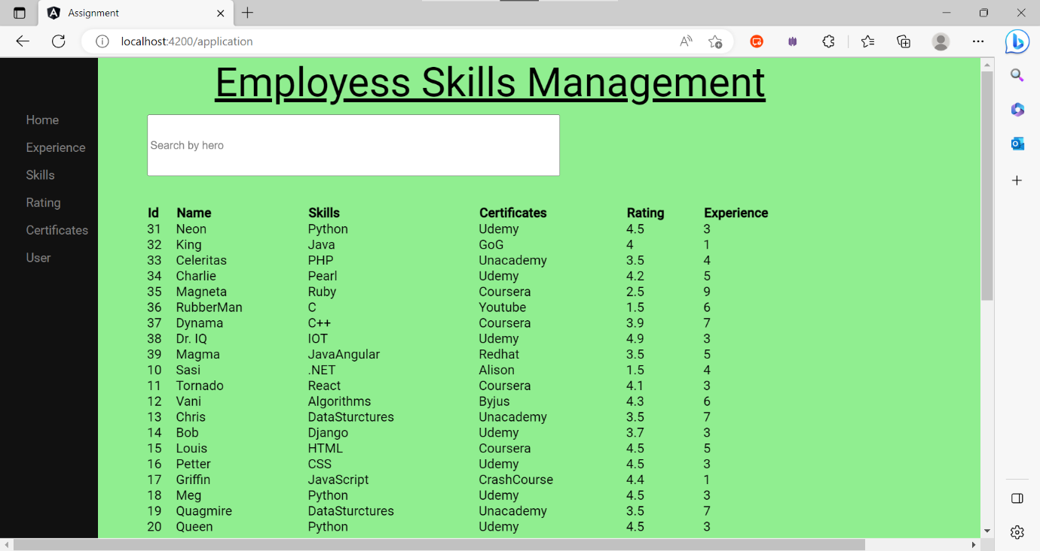

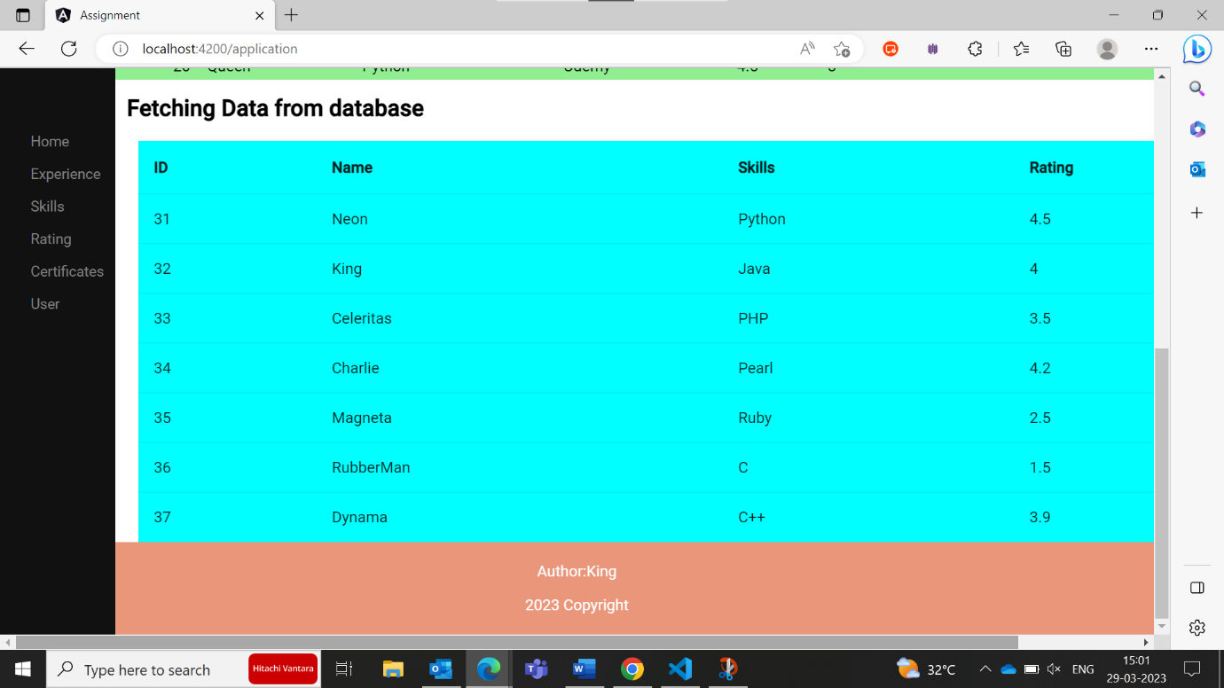

Home Page:

Dashboard:

User Data fetched from Database:

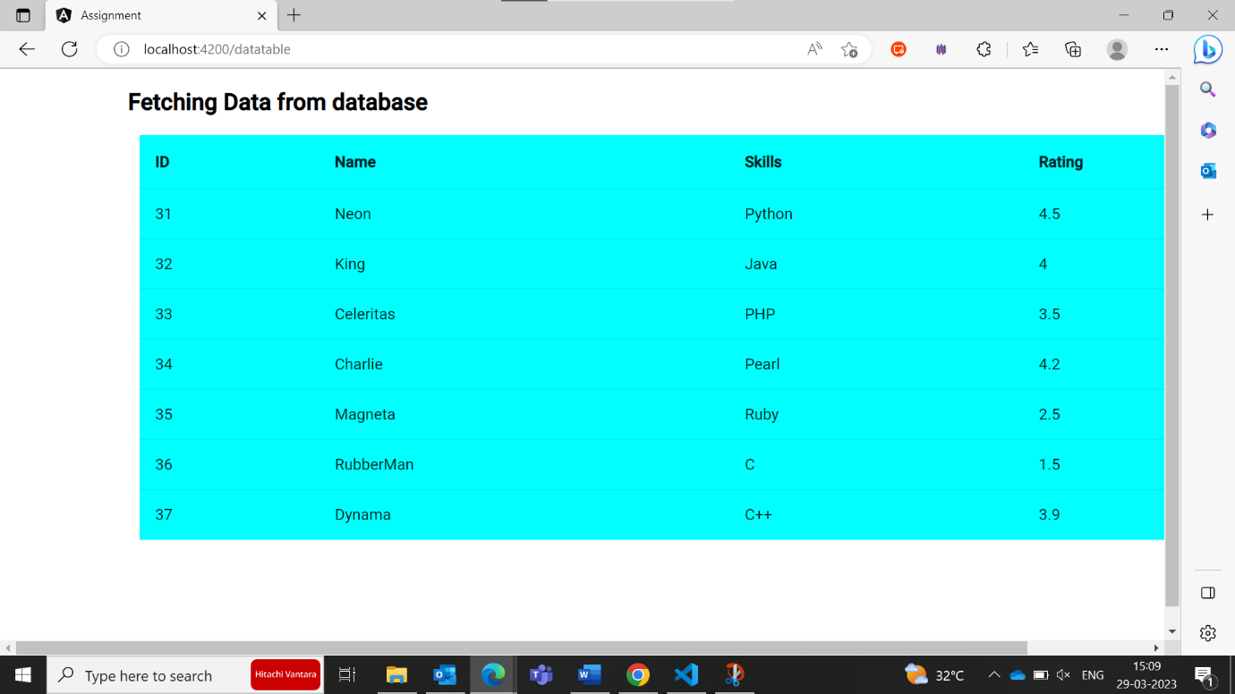

Search based on credentials:

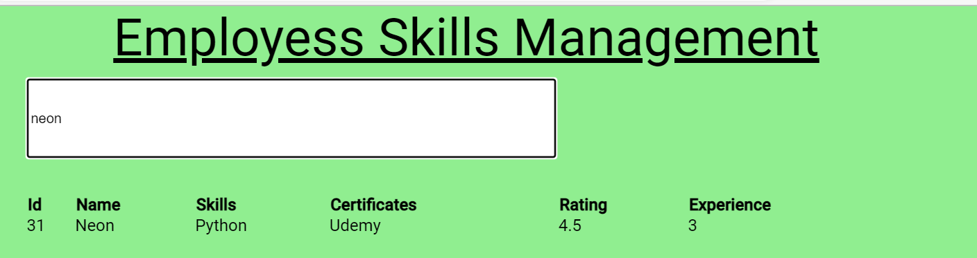

Error Handling and Exception:

Fetching Data from Json Server:

Implementing Security for the REST API

Content Security Policies (CSP)

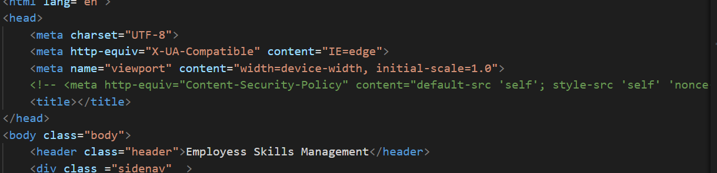

Preventing CSRF (Cross-site request forgery):

Using Module HttpClientXSrfModule for CSRF

Backend:

The Eclipse platform's Rest API is developed using Spring Boot. By building a Maven project for a Spring Boot application and using Postman to connect to the database, which uses PostgreSQL, data may be stored.

Creating REST API through Spring boot, PostgreSQL, JPA, Hibernate RESTful CRUD API:

Adding Data to POSTMAN

GET:

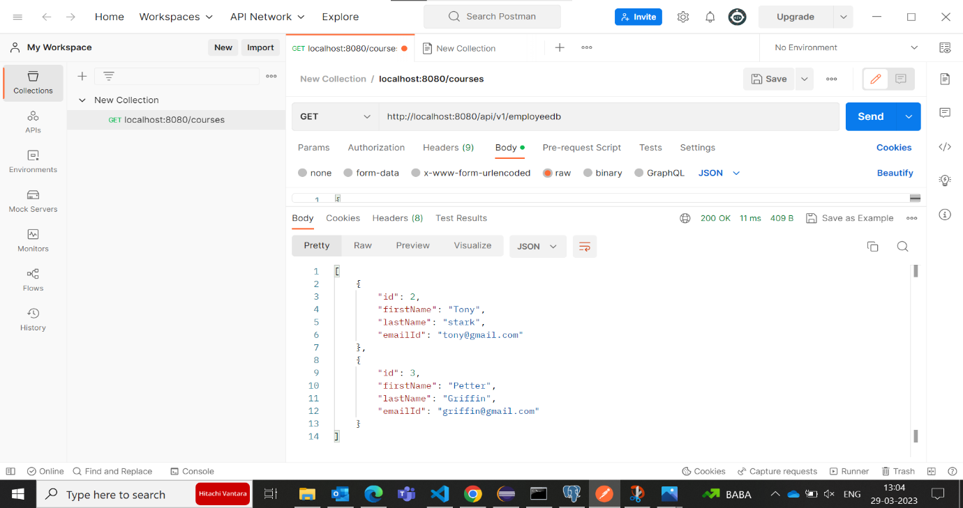

GET by Id:

POST:

DELETE:

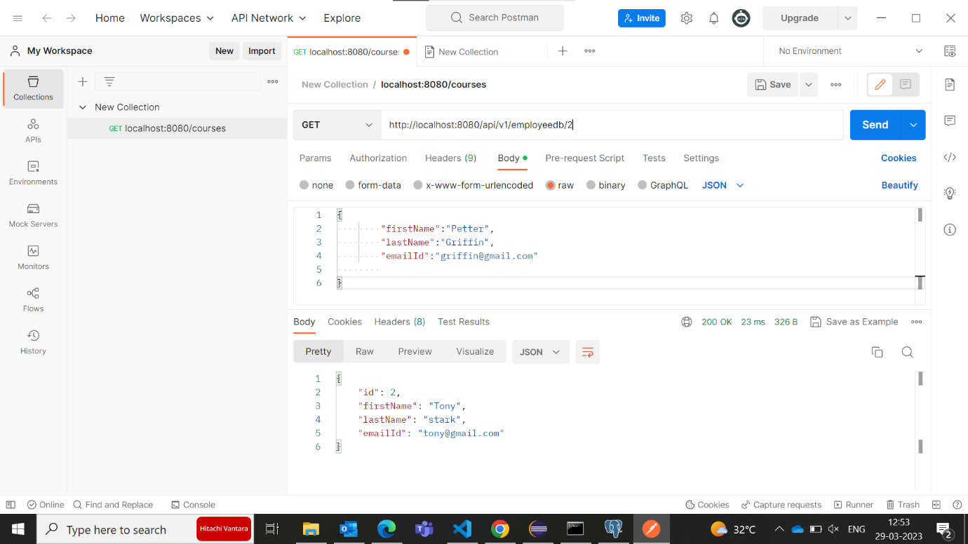

Database:

PostgreSQL:

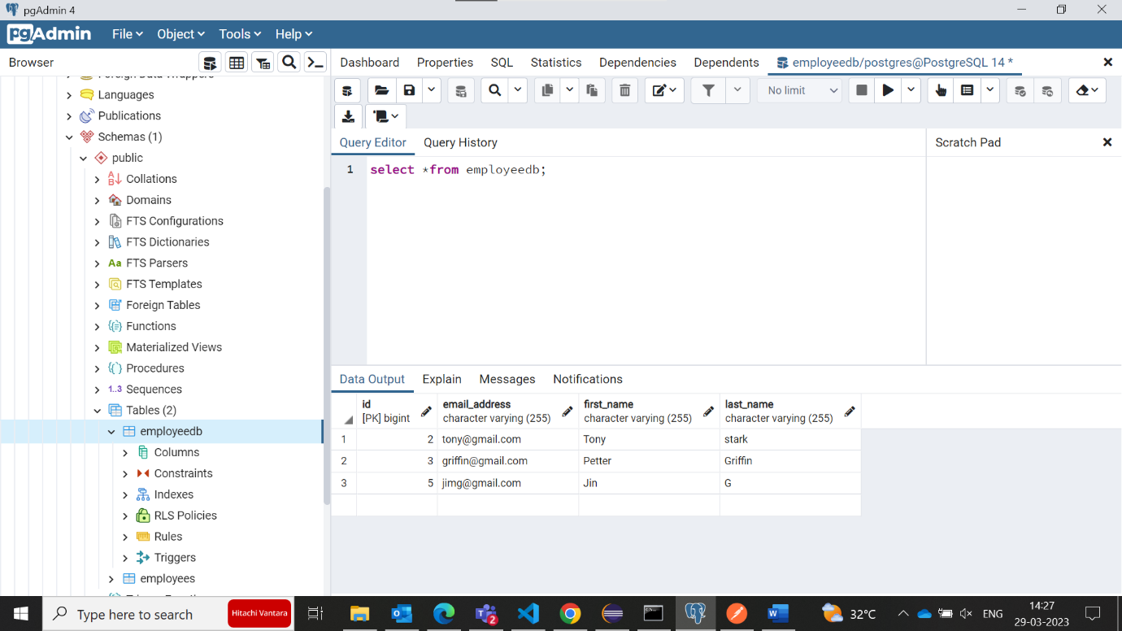

Creating REST API through Spring boot manually to json

AWS Deployment of Angular Application

Creating bucket in S3 and deploying.

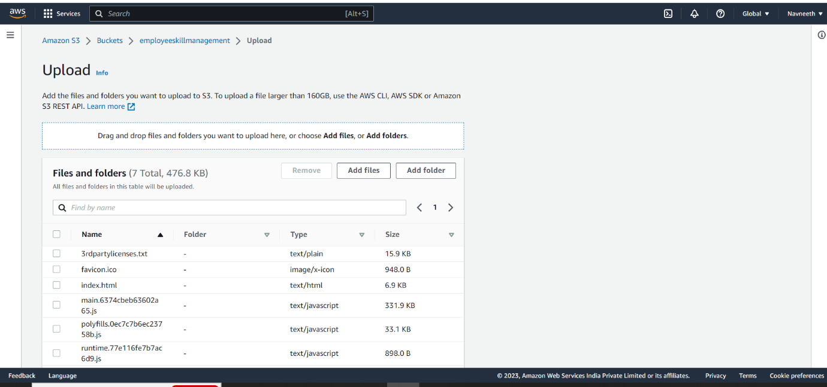

Application working through AWS

Conclusion: A web-based programme called the Employee Skill Management System will assist firms in managing employee skills and career development plans. The system will manage employee skills, offer a consolidated database for employee skills, and make information about employee skills accessible to all users. Java Angular, Node.js, and Spring Boot will be used to develop and deploy the system, respectively, utilising AWS.